1. Create one Jenkins job using the below code and create three stages.
- stage1: Git clone to download the source code.
- stage2: SonarQube Integration to check the quality of code.
- stage3: Slack Integration to send the alerts to slack.
Source Code: https://github.com/betawins/VProfile-1.git

Prerequisites checklist
1. Jenkins
- Jenkins server running
- Jenkins accessible in browser
- Java configured
2. Git
- Git installed on the Jenkins server
- Jenkins can clone GitHub repositories
3. Maven
- Maven installed on the Jenkins server
- Jenkins knows where Maven is
- 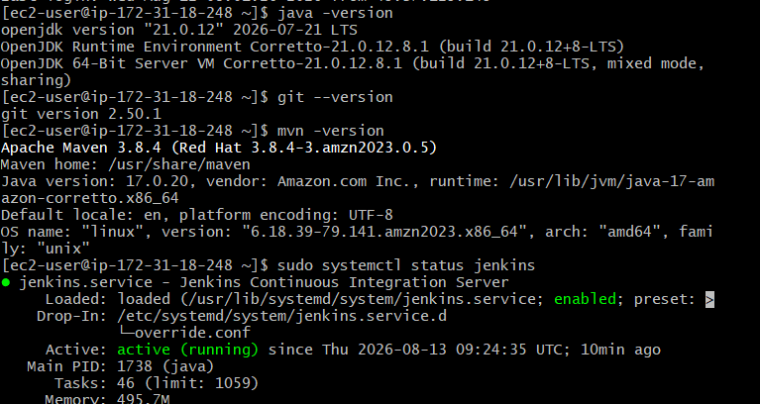
4. SonarQube
- SonarQube server running and accessible
- SonarQube configured in Jenkins
- SonarQube authentication token configured
- SonarQube Scanner/Maven integration available
5. Slack
- Slack workspace/channel available
- Jenkins Slack Notification plugin installed
- Slack integration/token configured in Jenkins
6. Jenkins plugins
At minimum, we'll check:
- Pipeline
- Git
- GitHub-related Git support
- SonarQube Scanner for Jenkins
- Slack Notification
- Credentials Binding

Part 1 — Launch SonarQube EC2

Step 1: Launch EC2
Go to:
AWS Console → EC2 → Instances → Launch instances
Set:
Name: SonarQube-Server
AMI: Amazon Linux 2023
Instance type: t3.small
Storage: 20 GB gp3
Use your existing key pair.
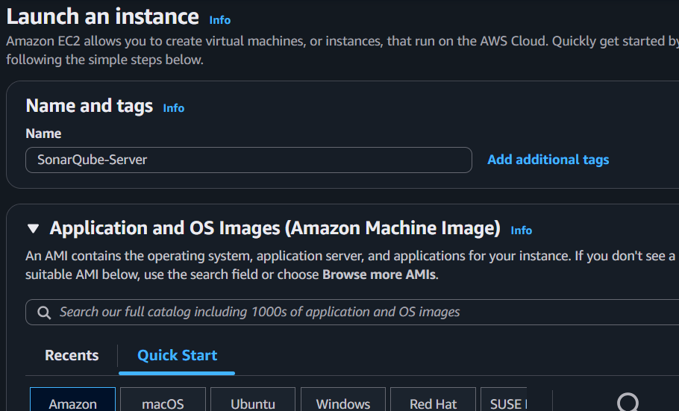
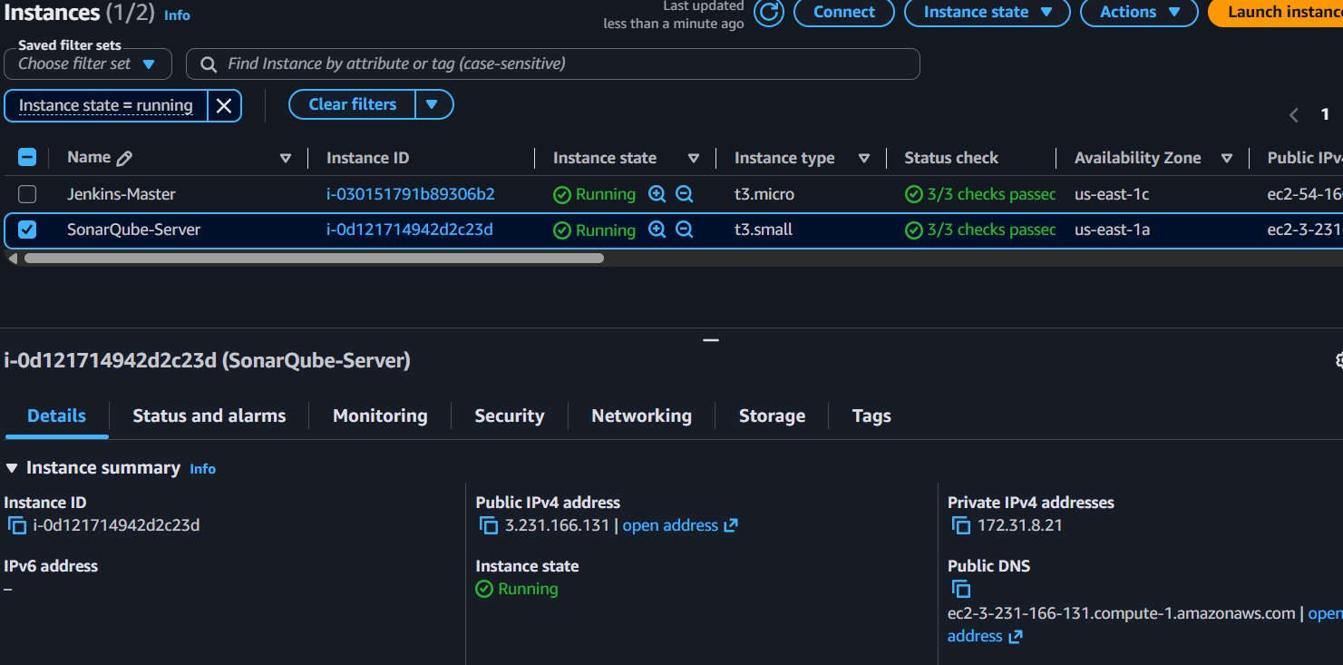

Part 2 — Configure Security Group
Create/use a security group such as:
Add:
Type | Port | Source
SSH | 22 | My IP
Custom TCP | 9000 | Jenkins Security Group
Port 9000 is SonarQube's web/application port.
Avoid opening port 9000 to 0.0.0.0/0 unless necessary.
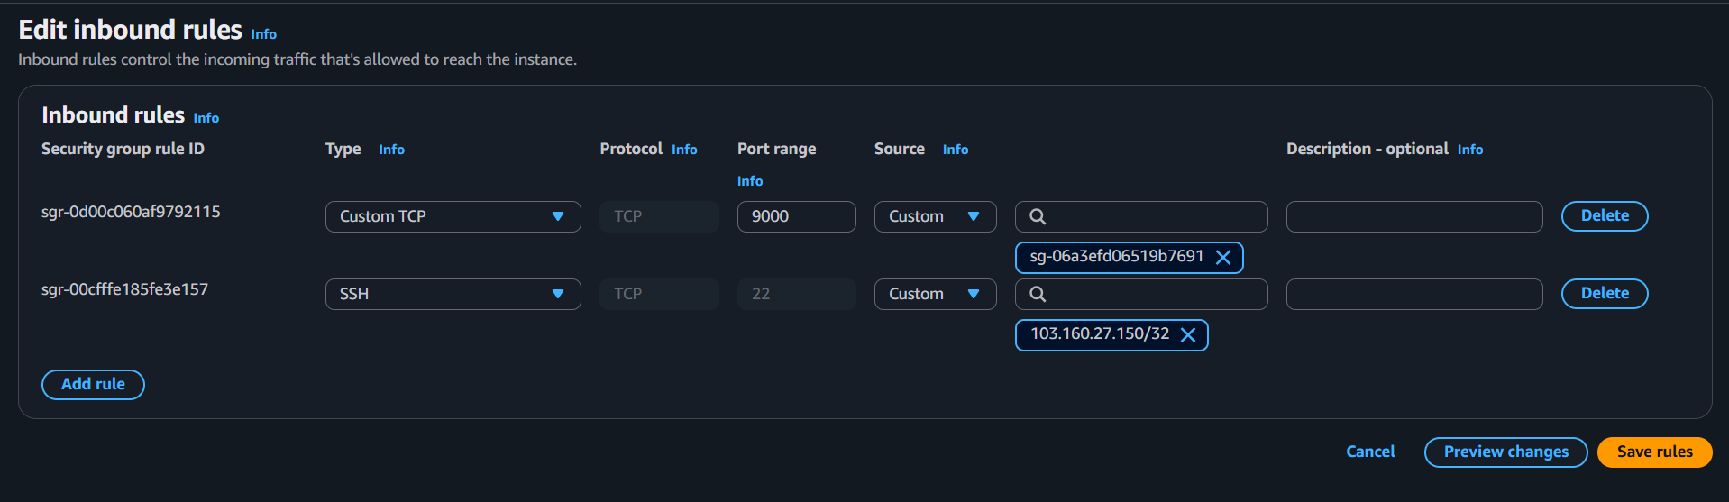

Part 3 — Connect to SonarQube EC2
Connect using SSH:
ssh -i your-key.pem ec2-user@<SONARQUBE_PUBLIC_IP>
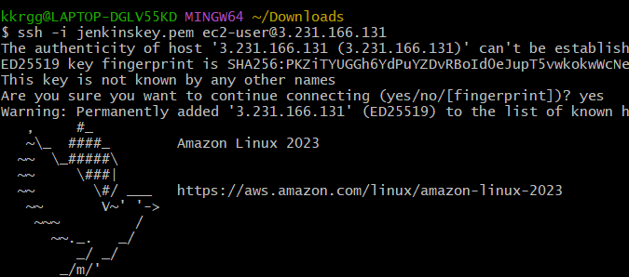
Verify the operating system:
cat /etc/os-release
Expected:
Amazon Linux 2023

Part 4 — Check System Resources
Check memory:
free -h
Check disk:
df -h /
For our setup we have approximately:
RAM: 2 GB
Disk: 20 GB
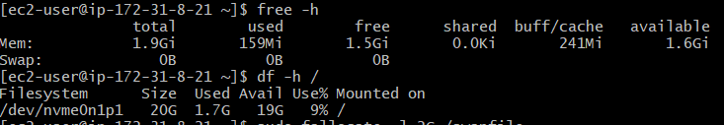

Part 5 — Configure Swap
Because the t3.small has only 2 GB RAM, create a 2 GB swap file.

Create swap
sudo fallocate -l 2G /swapfile
Set permissions:
sudo chmod 600 /swapfile
Create swap:
sudo mkswap /swapfile
Enable it:
sudo swapon /swapfile
Verify:
free -h
Expected:
Swap: 2.0Gi 0B 2.0Gi
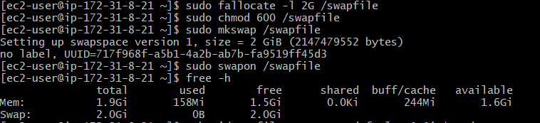

Make swap permanent
echo '/swapfile swap swap defaults 0 0' | sudo tee -a /etc/fstab
Verify:
swapon –show
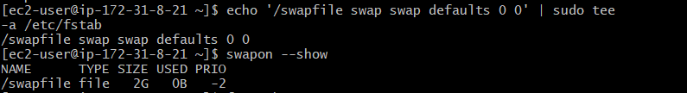

Part 6 — Install Java
Install:
sudo dnf install java-21-amazon-corretto -y
Check:
java -version
Expected:
openjdk version "21..."
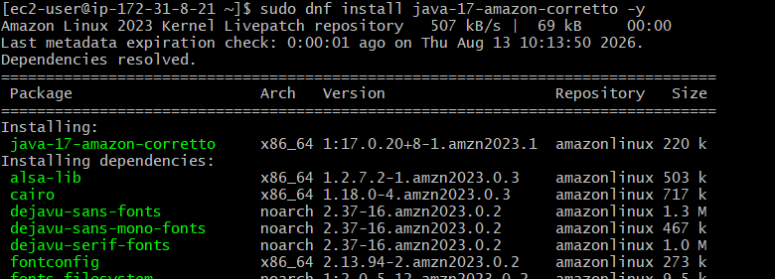

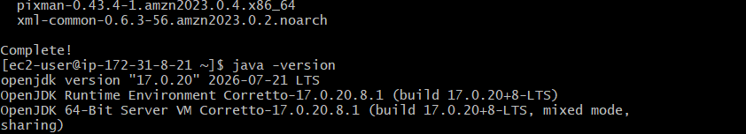

Part 7 — Configure JAVA_HOME
Find the Java path:
readlink -f $(which java)
For example:
/usr/lib/jvm/java-21-amazon-corretto.x86_64/bin/java
Set JAVA_HOME:
echo 'export JAVA_HOME=/usr/lib/jvm/java-21-amazon-corretto.x86_64' | sudo tee /etc/profile.d/java.sh
Load it:
source /etc/profile.d/java.sh
Verify:
echo $JAVA_HOME
Expected:
/usr/lib/jvm/java-21-amazon-corretto.x86_64
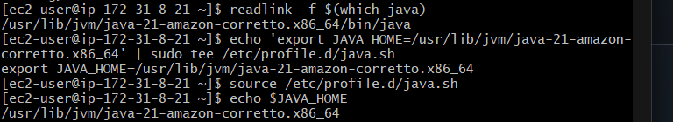

Part 8 — Create SonarQube User
SonarQube should not run as root.
Create a dedicated user:
sudo useradd -r -m -d /opt/sonarqube -s /bin/bash sonarqube
Verify:
id sonarqube
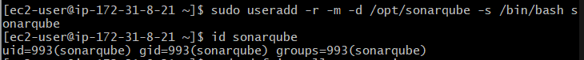

Part 9 — Install Required Utilities
Install wget and unzip:
sudo dnf install wget unzip -y
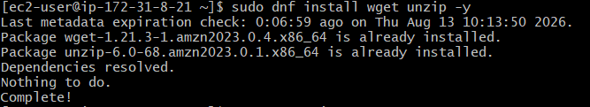
Verify:
wget –version
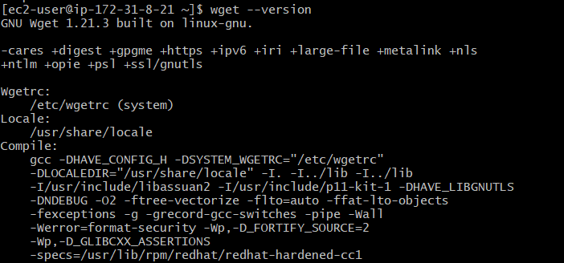
and:
unzip -v
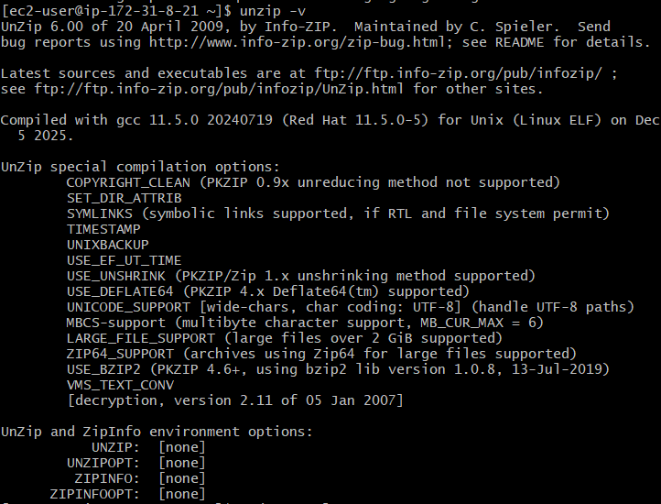

Part 10 — Configure Kernel Parameters
SonarQube uses Elasticsearch internally, so configure the required Linux parameters.
Run:
sudo sysctl -w vm.max_map_count=524288
Then:
sudo sysctl -w fs.file-max=131072
Verify:
sysctl vm.max_map_count
Expected:
vm.max_map_count = 524288
And:
sysctl fs.file-max
Expected:
fs.file-max = 131072

Make settings permanent
sudo tee /etc/sysctl.d/99-sonarqube.conf <<'EOF'
vm.max_map_count=524288
fs.file-max=131072
EOF
Apply:
sudo sysctl –system
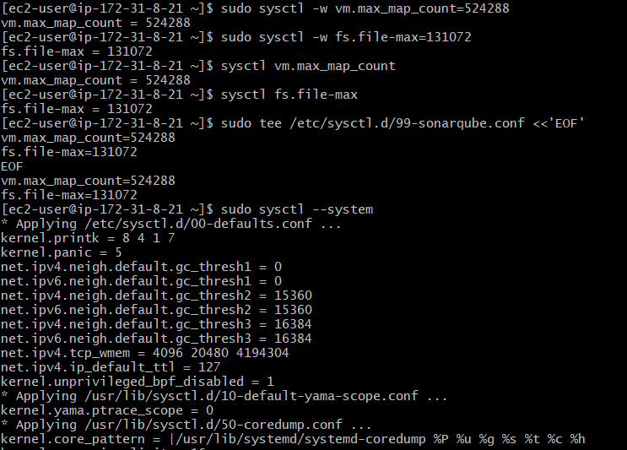

Part 11 — Download SonarQube
Go to /tmp:
cd /tmp
Download the SonarQube Community Build version we selected:
wget https://binaries.sonarsource.com/Distribution/sonarqube/sonarqube-26.8.0.126808.zip
Verify:
ls -lh /tmp/sonarqube-26.8.0.126808.zip
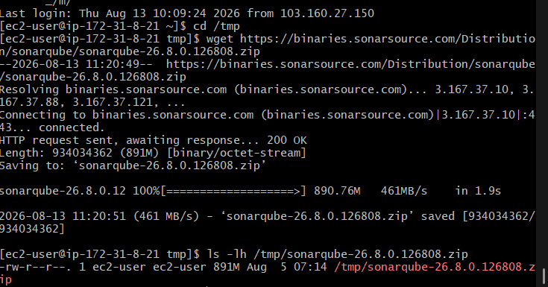

Part 12 — Extract SonarQube
Extract:
sudo unzip /tmp/sonarqube-26.8.0.126808.zip -d /opt/
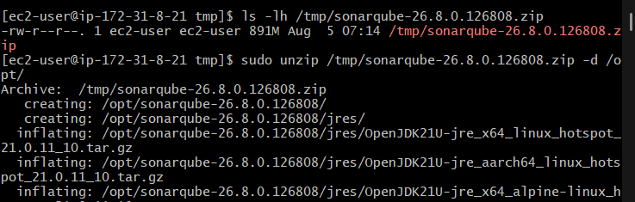
Check:
ls -ld /opt/sonarqube*
You should see:
/opt/sonarqube
/opt/sonarqube-26.8.0.126808
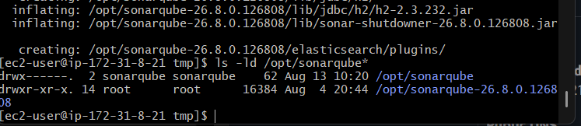

Part 13 — Configure SonarQube Directory
We want the final installation directory to be:
/opt/sonarqube
If the extracted directory is:
/opt/sonarqube-26.8.0.126808
move its contents into /opt/sonarqube.
Then assign ownership:
sudo chown -R sonarqube:sonarqube /opt/sonarqube
Verify:
ls -ld /opt/sonarqube
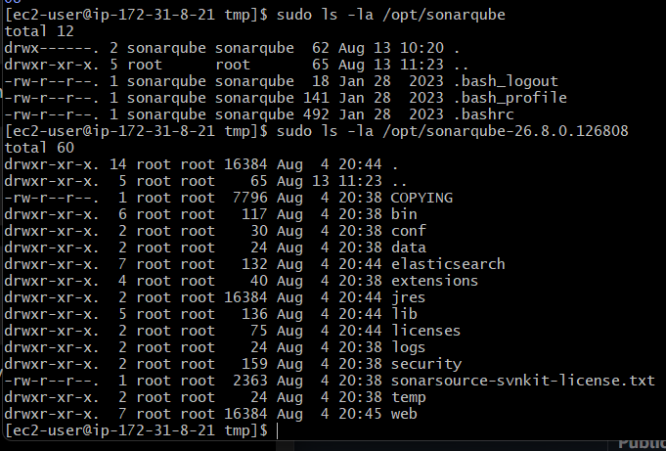

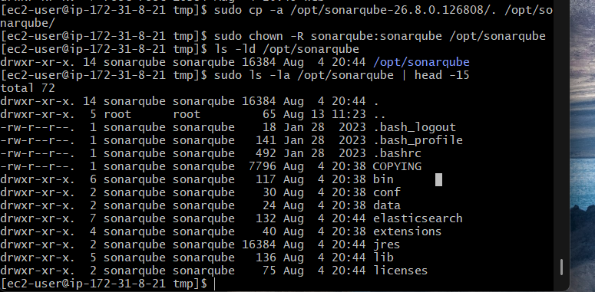

Part 14 — Configure SonarQube
The main configuration file is:
/opt/sonarqube/conf/sonar.properties

14.1 Open the configuration file
Run:
sudo vi /opt/sonarqube/conf/sonar.properties
Inside the file, find these lines:
#sonar.web.host=0.0.0.0
#sonar.web.port=9000
Change them to:
sonar.web.host=0.0.0.0
sonar.web.port=9000
Important: Remove the # at the beginning of those two lines.
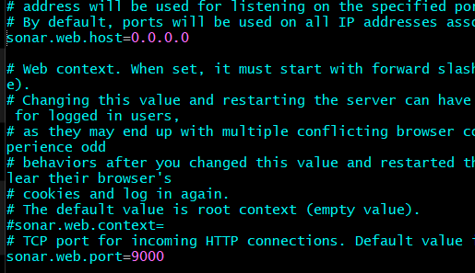

14.2 Save the file
If you're using vi:
- Press Esc
- Type:
:wq
- Press Enter

14.3 Verify the settings
Run:
grep -E '^[^#].*sonar.web.(host|port)' /opt/sonarqube/conf/sonar.properties
Expected:
sonar.web.host=0.0.0.0
sonar.web.port=9000
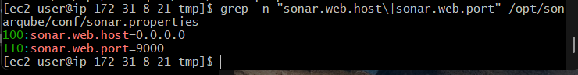

Why these settings?
- sonar.web.host=0.0.0.0 → allows SonarQube to listen on the server's network interfaces.
- sonar.web.port=9000 → SonarQube web interface uses port 9000

Part 15 — Create systemd Service
We'll create:
/etc/systemd/system/sonarqube.service

Command vi /etc/systemd/system/sonarqube.service

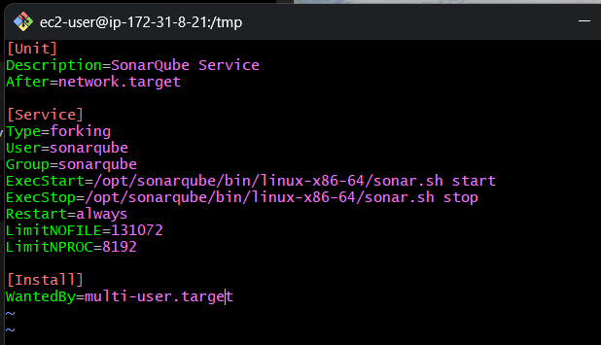
This allows us to manage SonarQube with:
sudo systemctl start sonarqube
sudo systemctl stop sonarqube
sudo systemctl restart sonarqube
sudo systemctl status sonarqube
sudo systemctl enable sonarqube

Part 16 — Start SonarQube
After configuration:
sudo systemctl daemon-reload
Start:
sudo systemctl start sonarqube
Check:
sudo systemctl status sonarqube
We want:
Active: active (running)
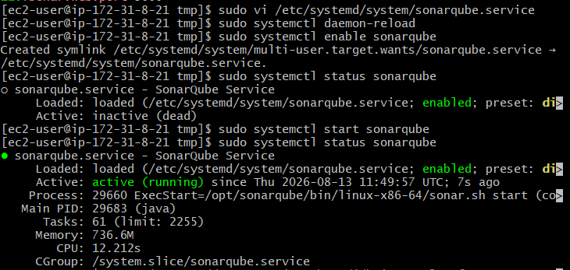

Part 17 — Verify Port 9000
Run:
sudo ss -lntp | grep 9000
Then:
curl -I http://localhost:9000
A response from SonarQube confirms that the service is listening.
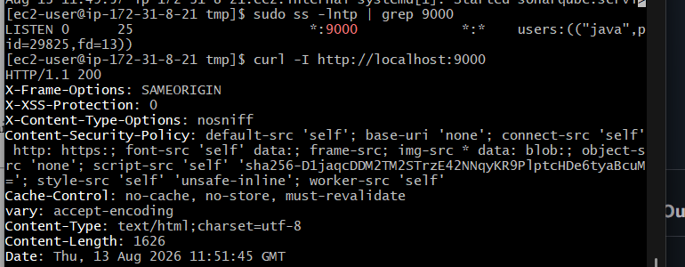

Part 18 — Access SonarQube Web Interface
From your browser:
http://<SONARQUBE_PUBLIC_IP>:9000
You should see the SonarQube login page.
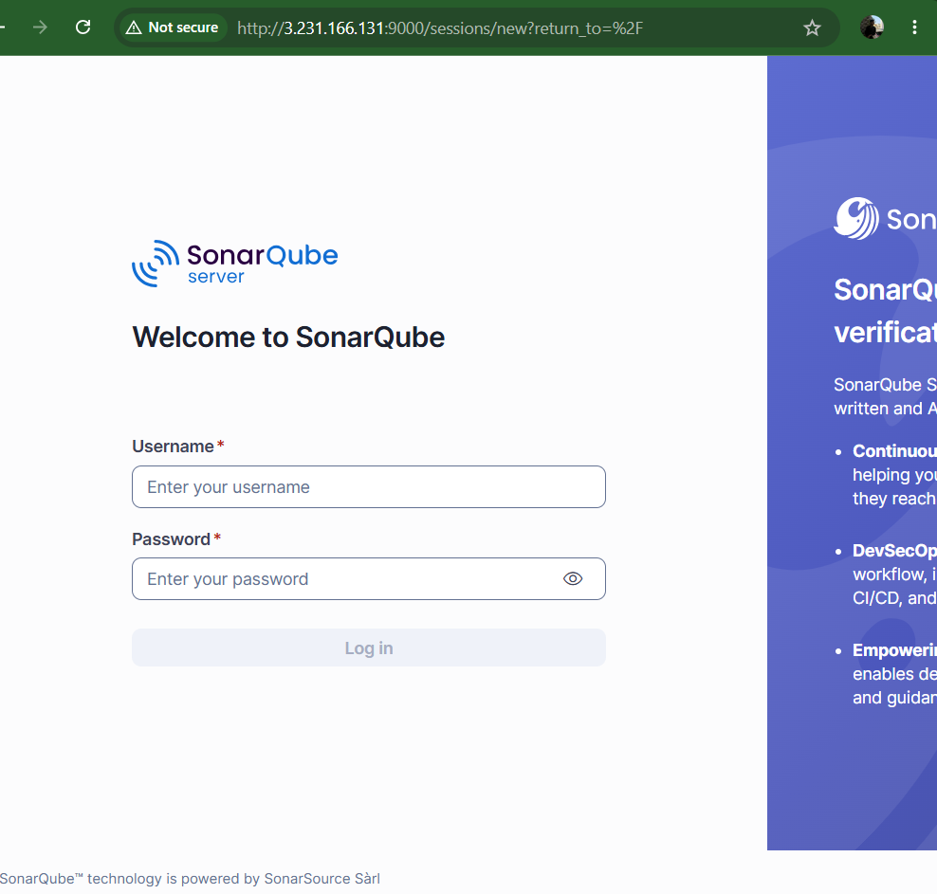
The default credentials are:
Username: admin
Password: admin
On first login, SonarQube will ask you to change the password.
SonarQube Integration Prerequisites

Step 19 — Create the VProfile Project in SonarQube
Now that the SonarQube server is running, we'll create the project that Jenkins will send the VProfile code analysis to.

19.1 Open SonarQube
Go to your SonarQube dashboard:
http://<SONARQUBE-PUBLIC-IP>:9000
Log in with your updated admin credentials.
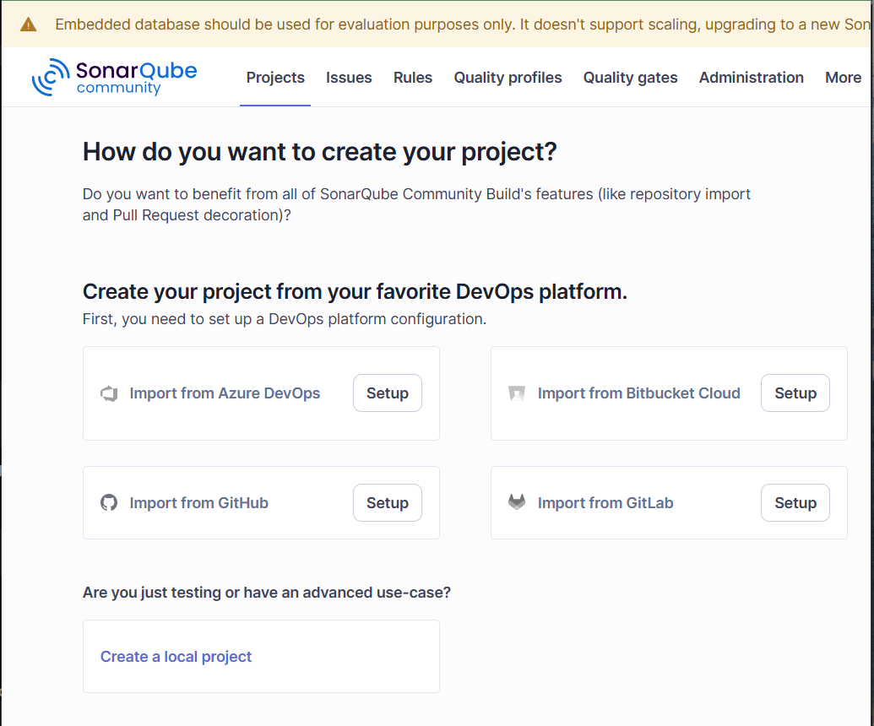

19.2 Create a local project
From the dashboard:
Projects → Create Project
Select:
Create a local project
Enter:
Project display name: VProfile
Project key: VProfile
The project key is important because we'll use it later in the Jenkins Pipeline:
-Dsonar.projectKey=VProfile
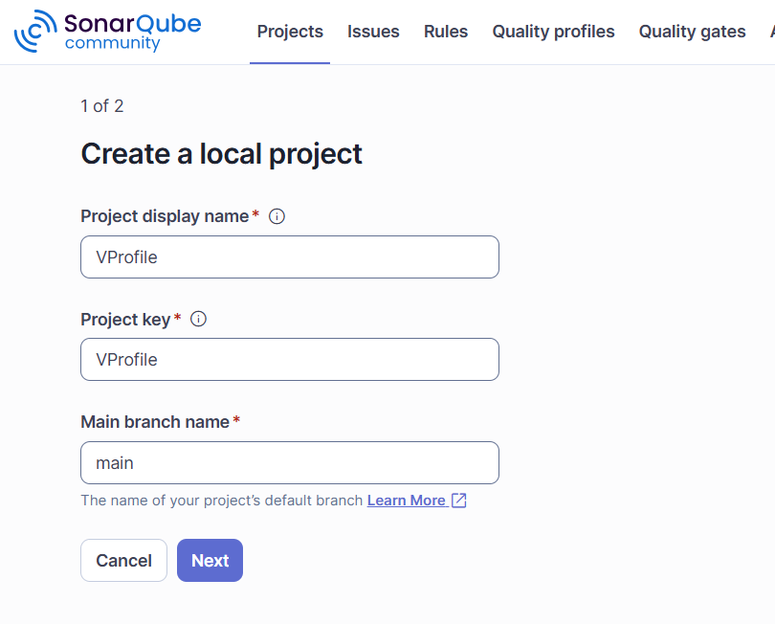

19.3 Create the project
Click Set Up / Create Project.
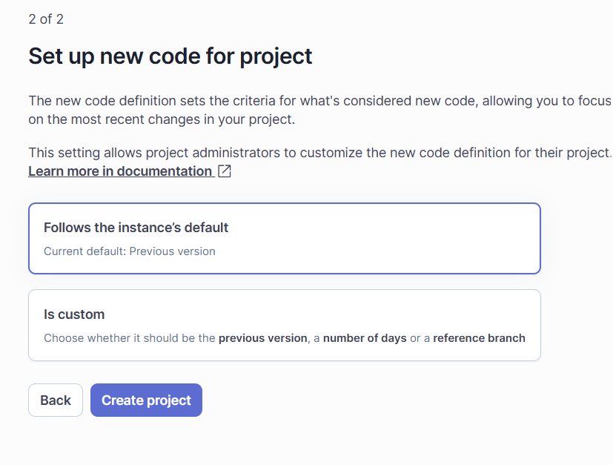
If SonarQube asks how you want to analyze the project, select:
Locally
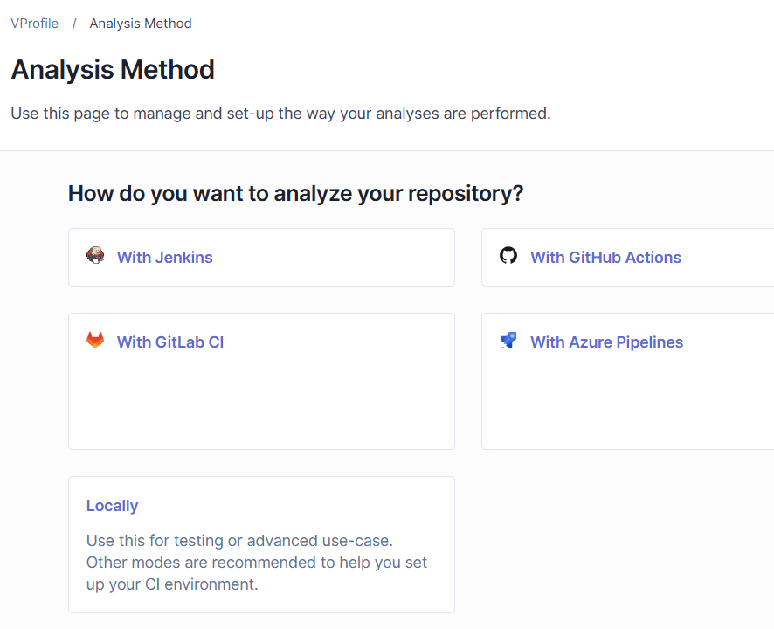
At the end, you should see the VProfile project in:
Projects → VProfile

Step 20 — Generate the VProfile project token
Token name:
You can change:
Analyze "VProfile"
to something clearer, for example:
jenkins-vprofile

Expiration
You currently have:
Expires in: 30 days
For this lab, you can leave it at 30 days.

Click:
Generate
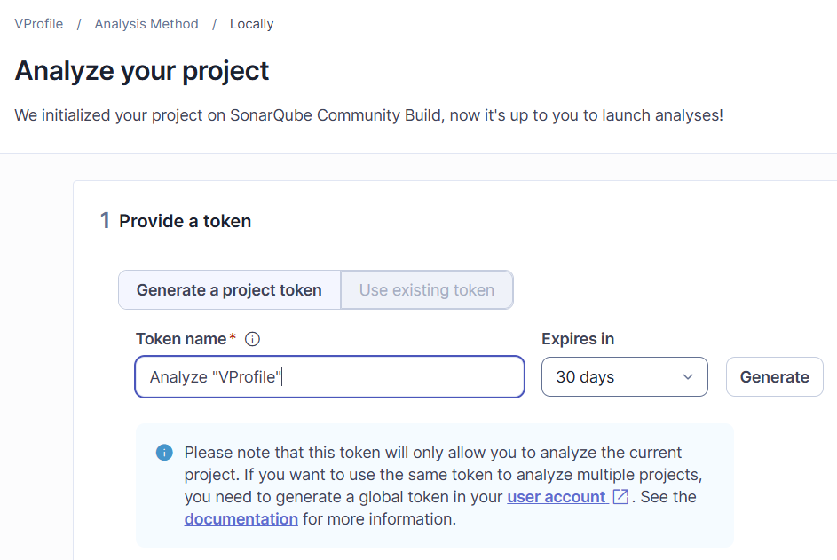

SonarQube will then display the token.
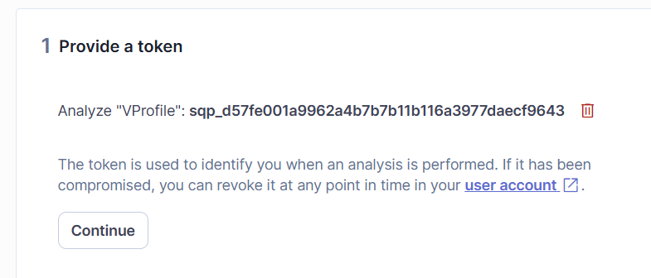

Slack Prerequisite:

Step 21: Create Slack Channel
Now let's prepare Slack before creating the Jenkins job.

21.1 Open Slack
Open your Slack workspace.
Create a channel named:
#jenkins-alerts
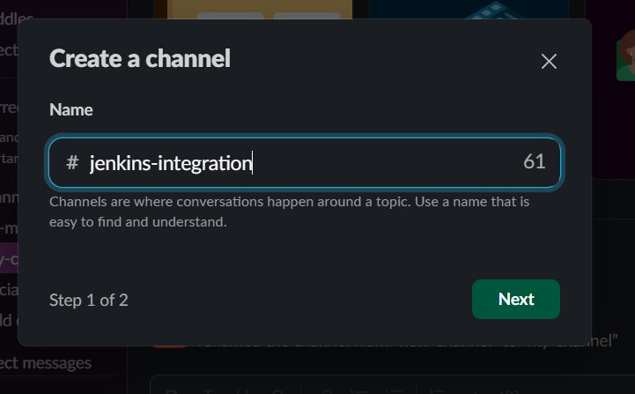
You can make it public or private. For this lab, either is fine.
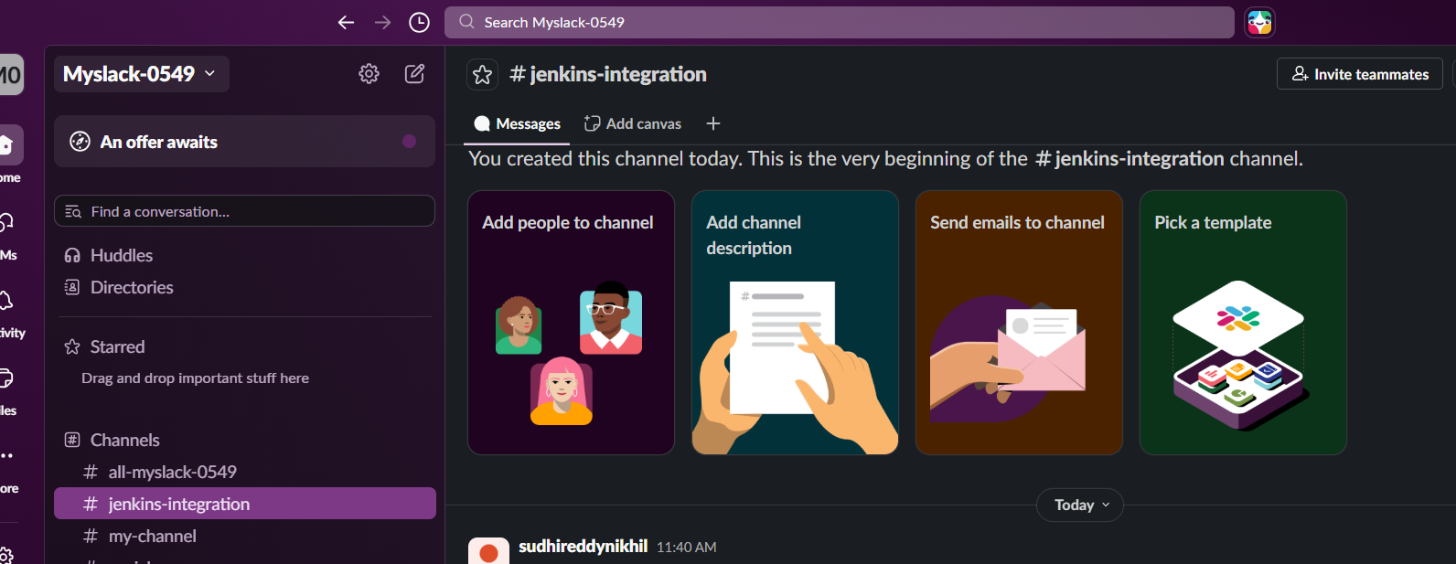

21.2 Why this channel?
Our Jenkins pipeline will eventually work like this:
GitHub
↓
Jenkins
↓
Stage 1: Git Clone
↓
Stage 2: SonarQube Analysis
↓
Stage 3: Slack Notification
↓
#jenkins-alerts
The Slack message will tell us whether the Jenkins build/analysis succeeded or failed.

Step 22 — Create Slack App for Jenkins
Now we'll create a Jenkins Slack bot. This bot is what allows Jenkins to send notifications into your #jenkins-integration channel.

22.1 Open Slack API
Open the official Slack Apps page:
Slack API — Your Apps
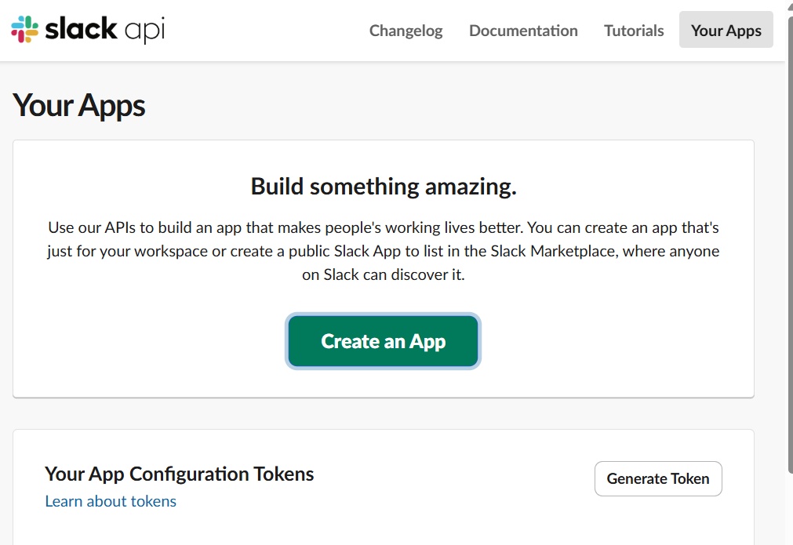
Sign in with the new personal Slack account/workspace you created.

22.2 Create a new app
On the Slack API page:
- Click Create New App
- Select From an app manifest
- Select your Slack workspace
- If Slack asks for a format, select YAML
You should now see an App Manifest editor.
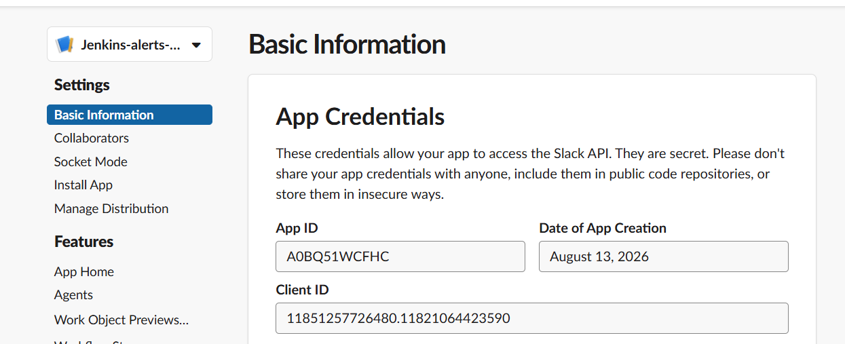

22.3 Configure OAuth Permissions
Go to:
Jenkins-alerts-App → OAuth & Permissions
Under:
Bot Token Scopes
add:
chat:write
This allows the Jenkins bot to send messages to Slack.
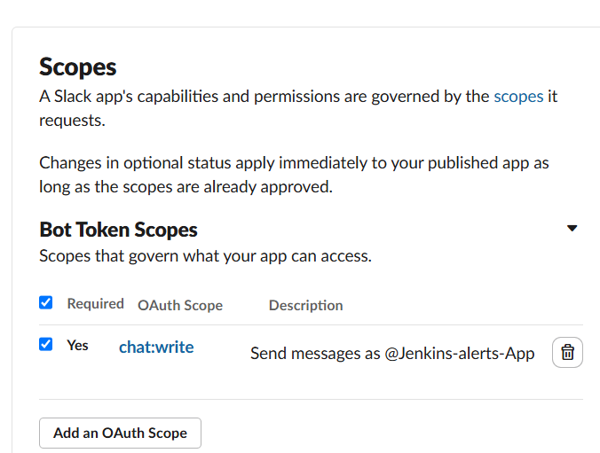

22.4 Create/Configure the Bot User
Go to:
Jenkins-alerts-App → App Home
Configure the bot user.
Example:
Display Name: Jenkins
Username: jenkins-alerts
Save the configuration.
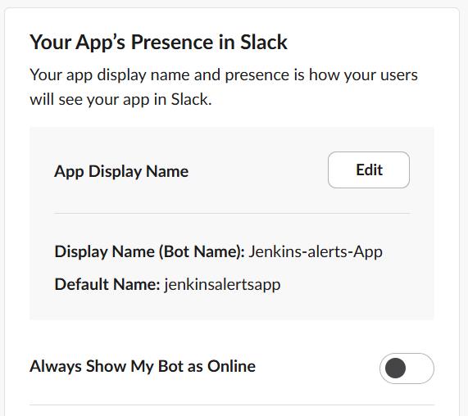

22.5 Install the App to the Workspace
Go to:
OAuth & Permissions
Click:
Install to Workspace
Review the requested permissions and click:
Allow
After installation, Slack generates:
Bot User OAuth Token
It starts with:
xoxb-
⚠️ Keep this token secret. Do not put it in GitHub, Jenkinsfiles, screenshots, or chat messages.

22.6 Open the Jenkins Integration Channel
In Slack, open:
#jenkins-integration
This is the channel we will use for Jenkins notifications.

22.7 Add Jenkins App to the Channel
Click the channel name and open:
Agents & apps
Click:
Add Agent or App
Search for:
Jenkins-alerts-App
Select the app.

22.8 Confirm Adding the App
Click Add / Add to channel.
Slack should display a confirmation similar to:
Jenkins-alerts-App was added to #jenkins-integration
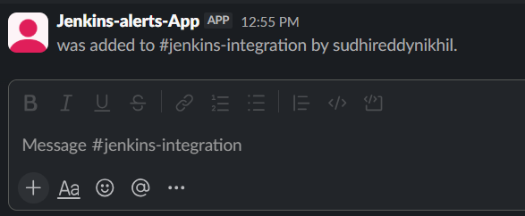

Step 23 — Install Slack Notification Plugin in Jenkins
Now we move to your Jenkins master EC2.

23.1 Open Jenkins
Open your Jenkins dashboard in the browser and log in with an administrator account.
Go to:
Dashboard → Manage Jenkins

23.2 Open Plugins
Click:
Plugins
Then select:
Available plugins

23.3 Search for Slack plugin
In the search box, type:
Slack Notification
Look for:
Slack Notification Plugin
This is the Jenkins plugin used to send build notifications to Slack. Jenkins Slack Notification Plugin

23.4 Install
Select the checkbox beside the plugin and click:
Install
If Jenkins gives you:
Install without restart
you can select that.
Wait until the installation completes.

23.5 Verify installation
Go to:
Manage Jenkins → Plugins → Installed plugins
Search:
Slack Notification
You should see the plugin listed as installed.
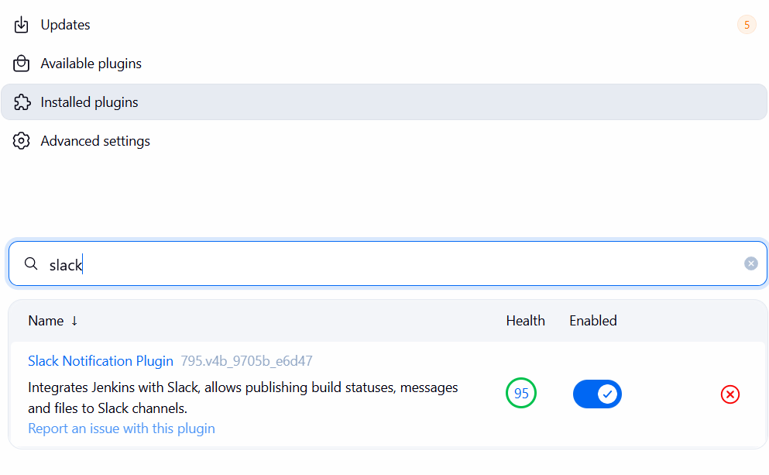

Step 24 — Add Slack Bot OAuth Token to Jenkins Credentials
Now we'll securely store the Bot User OAuth Token in Jenkins.
⚠️ Do not paste the xoxb-... token into the Jenkinsfile.

24.1 Open Jenkins Credentials
In Jenkins:
Dashboard → Manage Jenkins → Credentials
Then select:
System → Global credentials (unrestricted)
Click:
Add Credentials

24.2 Create the credential
Set:
Kind:
Secret text
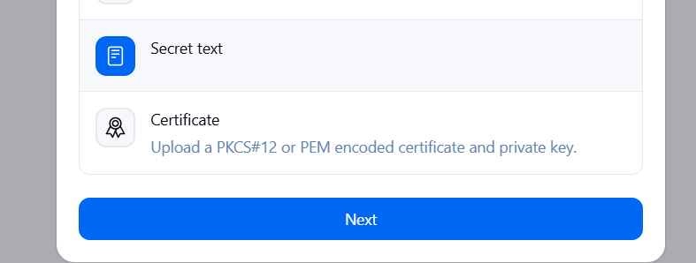
Secret:
Paste your Slack Bot User OAuth Token here.
It should start with:
xoxb-
ID:
Use:
slack-jenkins-token
Description:
Slack Bot OAuth Token for Jenkins notifications
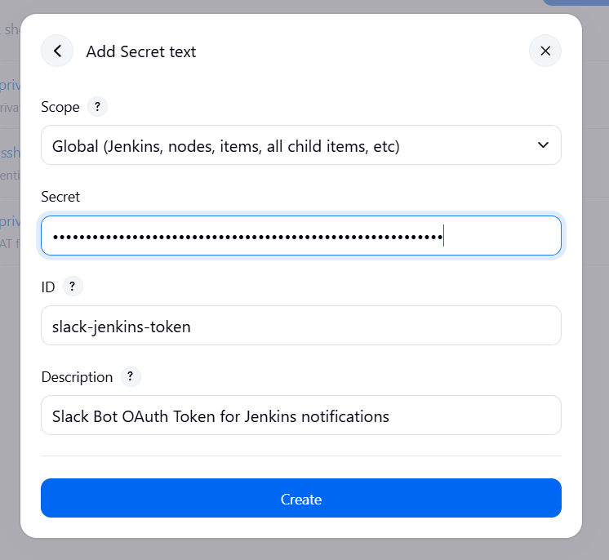
Then click:
Create

24.3 Verify
You should now see a credential similar to:
ID:
slack-jenkins-token

Kind:
Secret text

Description:
Slack Bot OAuth Token for Jenkins notifications
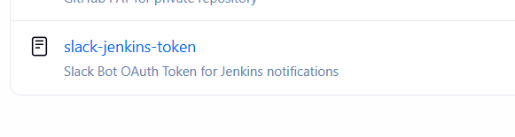

Step 25 — Configure Slack in Jenkins
Now we connect the Slack Notification Plugin to your Slack workspace.

25.1 Open Jenkins System Configuration
Go to:
Jenkins Dashboard → Manage Jenkins → System
Scroll down and look for:
Slack Notifications
If you don't see it, the plugin may not have installed correctly. Jenkins Slack Notification Plugin

25.2 Configure Slack Workspace
In Slack Notifications, configure the following.

Workspace
Enter your Slack workspace name:
Myslack-0549
Depending on the plugin version, this field may be called:
Workspace
or:
Team Domain
Use the workspace name/domain shown by your Slack workspace.

Credentials
Select:
slack-jenkins-token
This is the Secret Text credential we created in Step 24.

Default channel
Enter:
#jenkins-integration
or, if the field expects only the channel name:
jenkins-integration
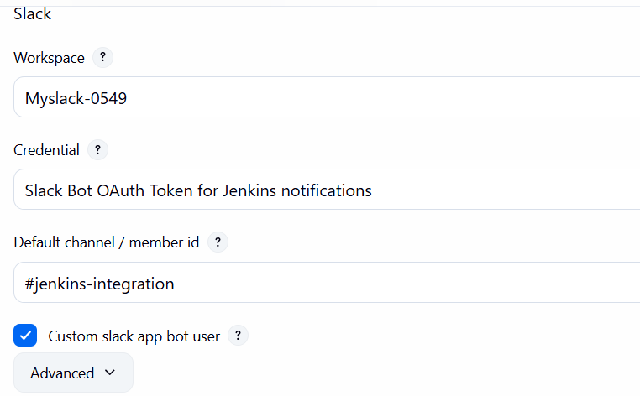

25.3 Important — Bot User
Look for an option such as:
Custom slack app bot user
or:
Bot User
Enable it if your plugin version provides that option.
This tells Jenkins to use your Jenkins-alerts-App bot rather than trying to send notifications as a user.

25.4 Save
Scroll to the bottom and click:
Save

Step 25.5 — Test the configuration
Depending on your installed Slack plugin version, you may see a:
Test Connection
button.
If available, click it.
A successful result should indicate that Jenkins can communicate with Slack.
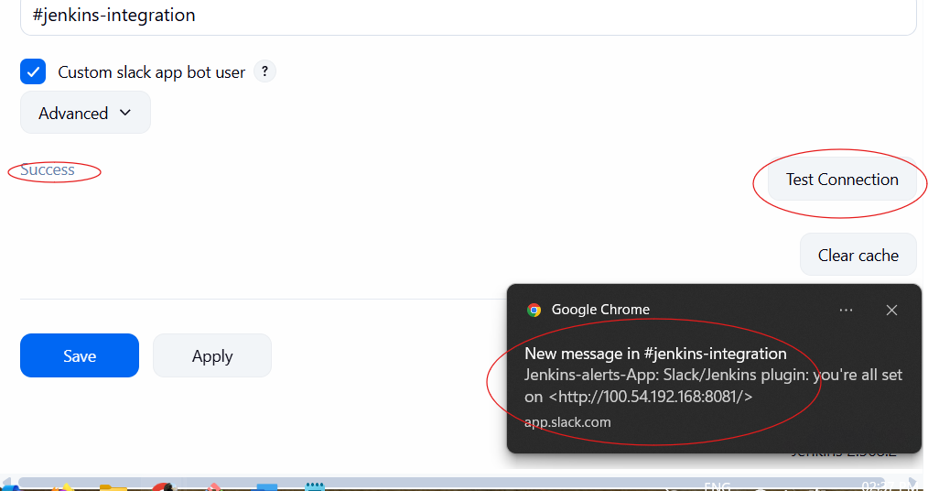
Then check:
#jenkins-integration
You should receive a test notification from Jenkins-alerts-App.
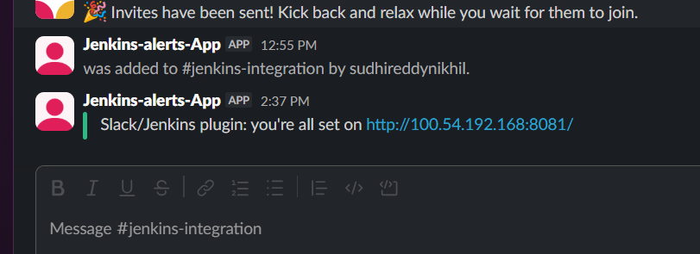

Step 26 — Verify GitHub Repository
Repository:
https://github.com/betawins/VProfile-1.git

26.1 Run Git verification
On the Jenkins master EC2, run:
git ls-remote https://github.com/betawins/VProfile-1.git

26.2 Expected output
You should see Git references similar to:
<commit-id> HEAD
<commit-id> refs/heads/master
The commit ID will be different for your repository.
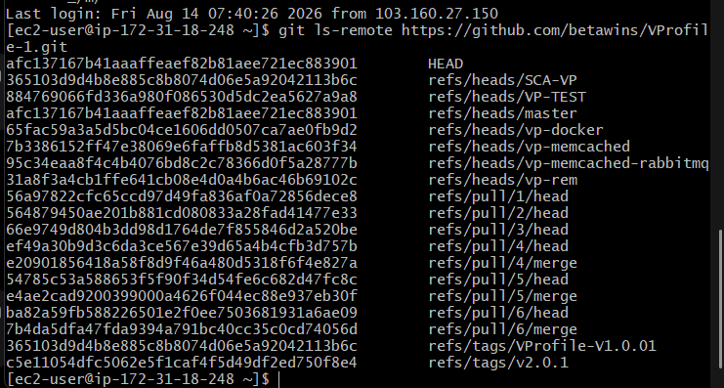
If the command returns the repository references without an error:
GitHub access → SUCCESS ✅
Repository access → SUCCESS ✅

Step 27 — Configure Jenkins ↔ SonarQube
Now we connect your Jenkins master to the SonarQube server.
We already have:
SonarQube Server → Running on port 9000 ✅
Jenkins Server → Running ✅

27.1 Get SonarQube Server URL
Your SonarQube is running on the separate EC2 instance.
Find its private IP:
hostname -I
Suppose it returns:
172.31.8.21
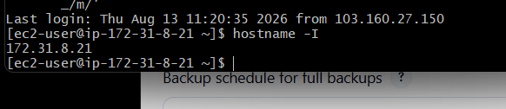
SonarQube URL will be:
http://172.31.8.21:9000
Use our actual SonarQube EC2 private IP.

Install SonarQube Scanner for Jenkins

1. Go to:
Jenkins Dashboard → Manage Jenkins → Plugins

2. Open:
Available plugins

3. Search:
SonarQube Scanner
Look for:
SonarQube Scanner for Jenkins
Install it.
If Jenkins shows Install without restart, select it.
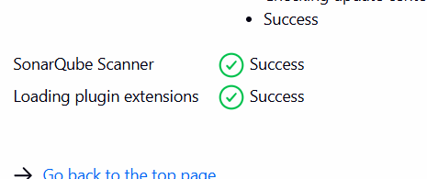

4. Wait for installation to finish
Then go to:
Manage Jenkins → System

5. Search the page for:
SonarQube
You should now find:
SonarQube servers
with an Add SonarQube button.

27.2 Open Jenkins System Configuration
In Jenkins:
Dashboard → Manage Jenkins → System
Find:
SonarQube servers
Click:
Add SonarQube
Enter:
Name:
SonarQube
Server URL:
http://<SONARQUBE-PRIVATE-IP>:9000
For example:
http://172.31.8.21:9000

27.3 Add SonarQube Authentication
Under Server authentication token, click:
Add → Jenkins
Create a credential:
Kind:
Secret text
Secret:
Paste your SonarQube token.
ID:
sonarqube-token
Description:
SonarQube authentication token
Click:
Add
Then select:
sonarqube-token
in the Server authentication token field.
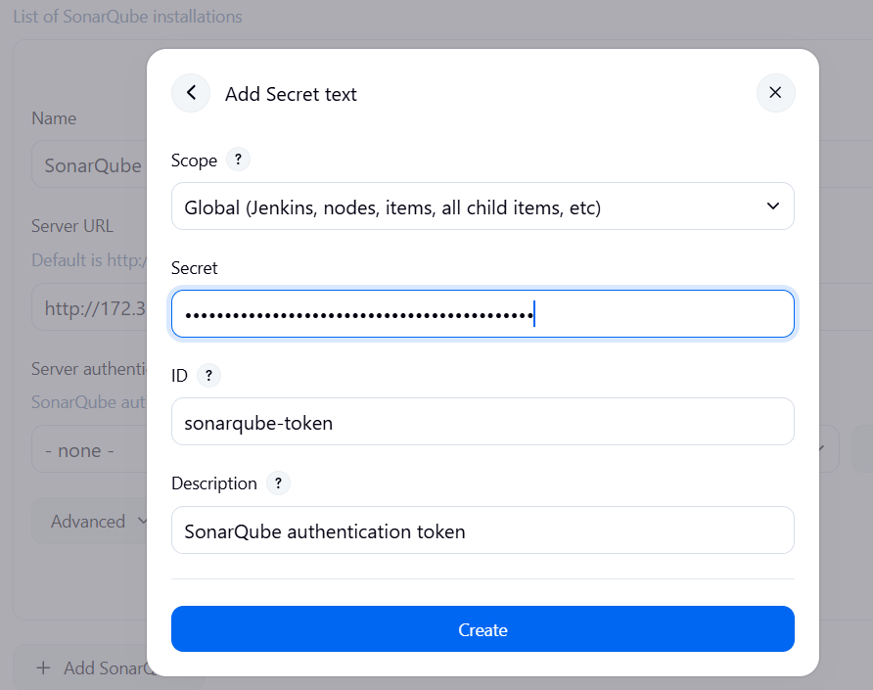

27.4 Save Jenkins Configuration
Scroll to the bottom and click:
Save
our configuration should now look like:
SonarQube Name:
SonarQube

Server URL:
http://<SonarQube-private-IP>:9000

Authentication:
sonarqube-token
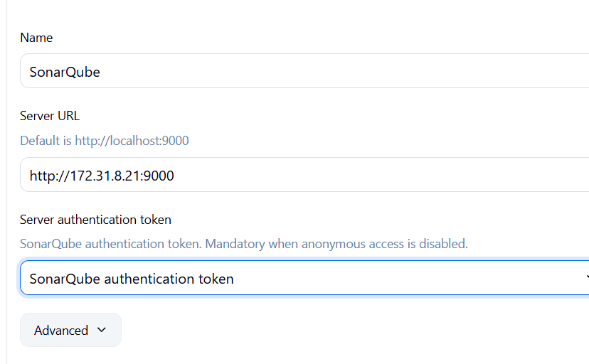

Step 28 — Configure Maven and SonarQube Scanner
This is the last prerequisite step before creating the Jenkins job. We will only do the required configuration.

28.1 Configure Maven in Jenkins
Go to:
Jenkins → Manage Jenkins → Tools
Find:
Maven installations
Click:
Add Maven
Enter:
Name: Maven-3.8.4
Select:
Install automatically
Then select the Maven version available in the list, preferably:
3.8.4
Click Save.
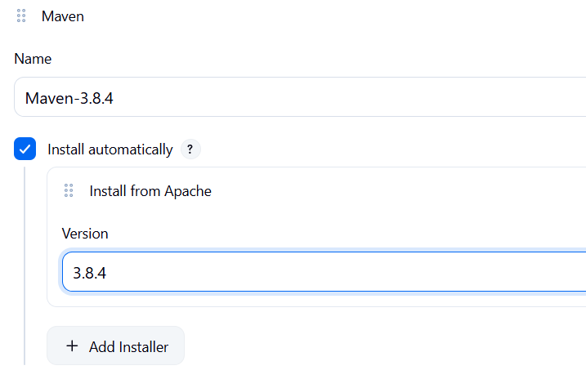

28.2 Configure SonarQube Scanner
On the same Tools page, find:
SonarQube Scanner installations
Click:
Add SonarQube Scanner
Enter:
Name: SonarQube-Scanner
Select:
Install automatically
Then select the available scanner version.
Click Save.
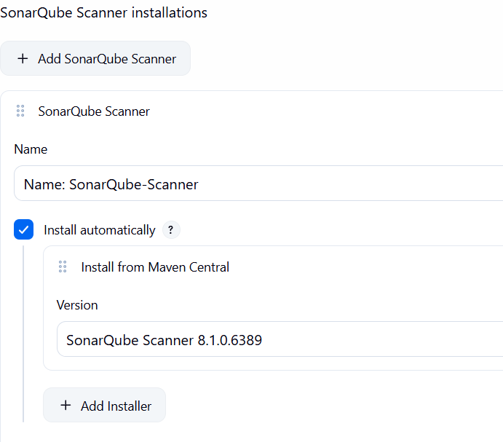

Step 29 — Create Jenkins Pipeline Job

29.1 Open Jenkins Dashboard
Go to your Jenkins dashboard.
Click:
New Item

29.2 Enter job name
Enter:
VProfile-SonarQube-Slack

29.3 Select job type
Select:
Pipeline
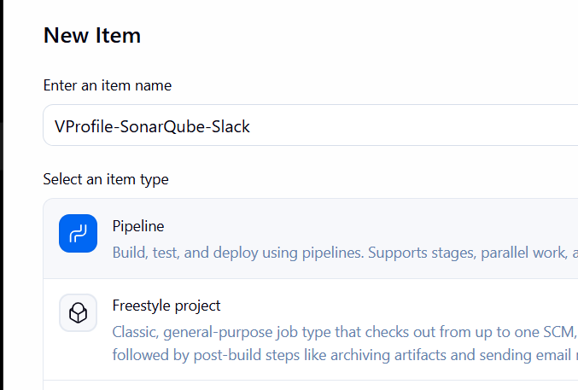
Then click:
OK

29.4 Configure the Pipeline
Scroll down to the Pipeline section.
For:
Definition
select:
Pipeline script

Step 29.5 — Confirm the Pipeline section
Your screen should be:
Pipeline
├── Definition: Pipeline script
└── Script: [empty]
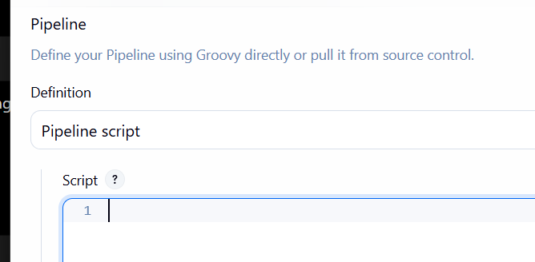

Step 30 — Stage 1: Git Clone
We will now configure the first stage of the pipeline.
For Job 1, the repository is:
https://github.com/betawins/VProfile-1.git
In the Script box, enter this initial pipeline:
pipeline {
agent any

stages {

stage('Git Clone') {
steps {
git 'https://github.com/betawins/VProfile-1.git'
}
}

}
}

After that save the job.
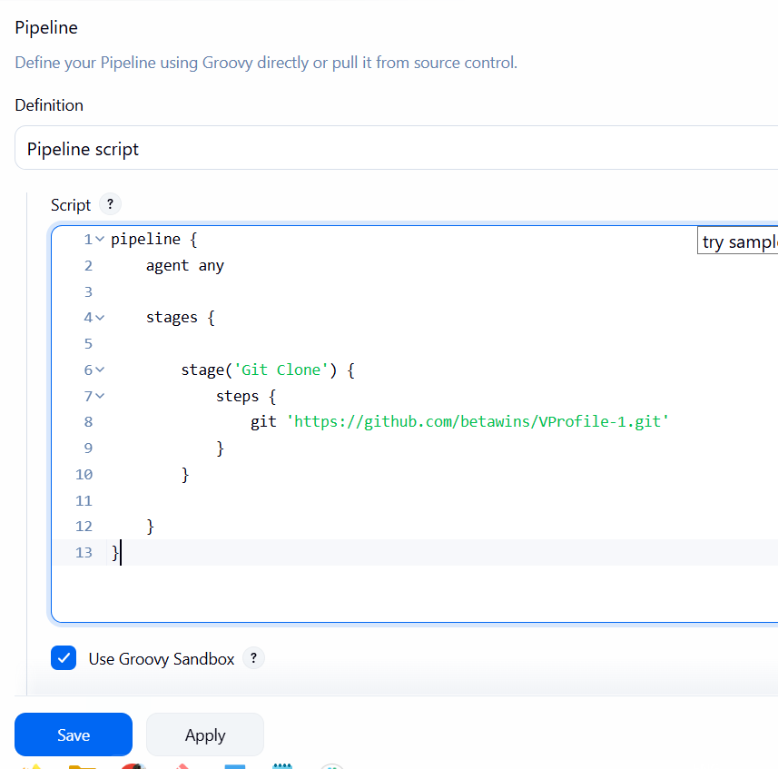

Step 31 — Configure SonarQube Analysis
we can add Stage 2.
You already have:
JDK : JDK-21
Maven : Maven-3.8.4
SonarQube Scanner : SonarQube-Scanner
SonarQube Server : SonarQube

31.1 Open the Pipeline
Go to:
Jenkins → VProfile-SonarQube-Slack → Configure
Find the Script section.
Your current Step 30 script is:
pipeline {
agent any

stages {

stage('Git Clone') {
steps {
git 'https://github.com/betawins/VProfile-1.git'
}
}

}
}

31.2 Replace it with the following
pipeline {
agent any

tools {
jdk 'JDK-21'
maven 'Maven-3.8.4'
}

stages {

stage('Git Clone') {
steps {
git 'https://github.com/betawins/VProfile-1.git'
}
}

stage('SonarQube Analysis') {
steps {
withSonarQubeEnv('SonarQube') {
sh '''
mvn clean verify sonar:sonar \
-Dsonar.projectKey=VProfile-1 \
-Dsonar.projectName=VProfile-1
'''
}
}
}

}
}

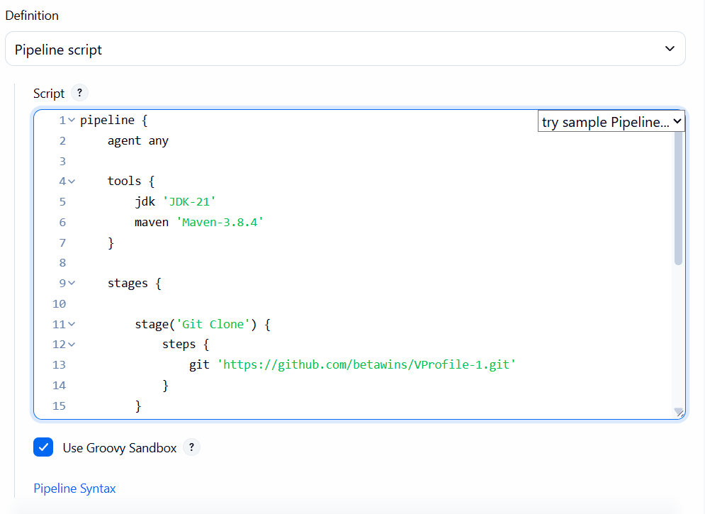

What Stage 2 does
Git Clone
↓
Maven builds the application
↓
SonarQube analyzes the source code
↓
SonarQube Server
↓
Quality analysis results

31.3 Save
Click:
Save

Step 32 — Add Slack Integration
Now we'll add the third and final stage to send the Jenkins result to:
#jenkins-integration
Go to:
Jenkins → VProfile-SonarQube-Slack → Configure → Script
Replace the current script with this:
pipeline {
agent any

tools {
jdk 'JDK-21'
maven 'Maven-3.8.4'
}

stages {

stage('Git Clone') {
steps {
git 'https://github.com/betawins/VProfile-1.git'
}
}

stage('SonarQube Analysis') {
steps {
withSonarQubeEnv('SonarQube') {
sh '''
mvn clean verify sonar:sonar \
-Dsonar.projectKey=VProfile-1 \
-Dsonar.projectName=VProfile-1
'''
}
}
}

stage('Slack Notification') {
steps {
slackSend(
channel: '#jenkins-integration',
message: "Jenkins Job: ${env.JOB_NAME}\nBuild: #${env.BUILD_NUMBER}\nStatus: ${currentBuild.currentResult}\nBuild URL: ${env.BUILD_URL}"
)
}
}

}
}

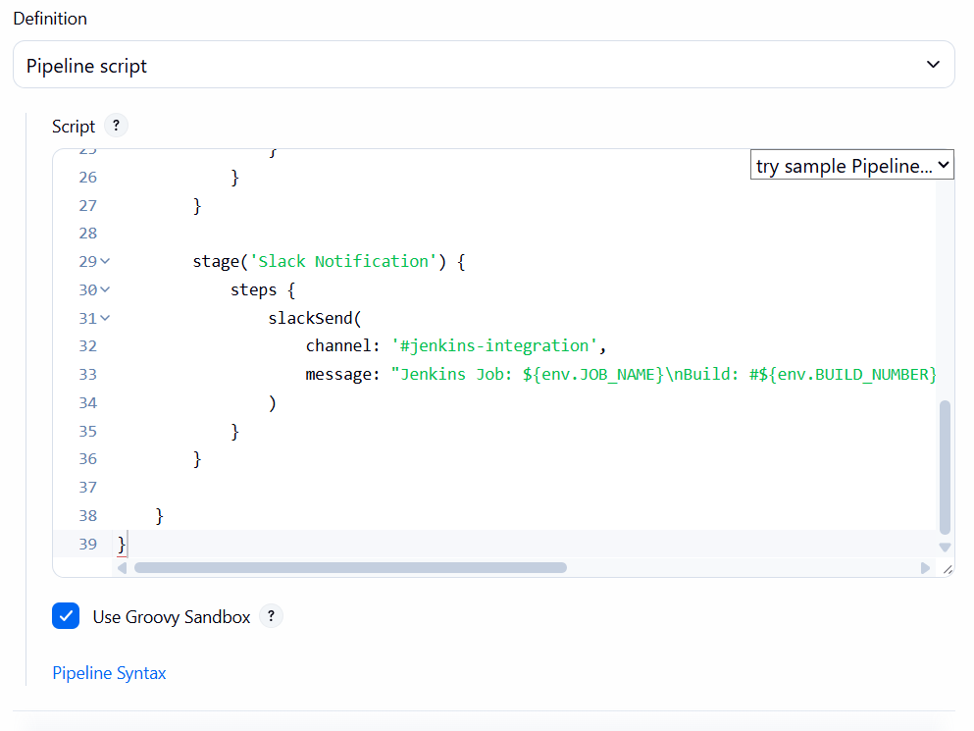

What Stage 3 does
After the SonarQube stage finishes, Jenkins sends a message to:
Jenkins
↓
Slack Notification Plugin
↓
Jenkins-alerts-App
↓
#jenkins-integration
The Slack message will contain:
Jenkins Job: VProfile-SonarQube-Slack
Build: #1
Status: SUCCESS
Build URL: ...

32.1 Save
Click:
Save

Step 33 — Run the Complete Pipeline
Now we test the entire flow.

33.1 Open the Jenkins job
Go to:
Jenkins Dashboard → VProfile-SonarQube-Slack
Click:
Build Now
A new build should appear, for example:
#1

33.2 Open Console Output
Click the build number:
#1
Then click:
Console Output
Watch the execution.
You should see the stages execute in this order:
Git Clone
↓
SonarQube Analysis
↓
Slack Notification

33.3 Expected result
At the end of the console output, we want:
Finished: SUCCESS
And in Slack:
#jenkins-integration

Jenkins Job: VProfile-SonarQube-Slack
Build: #1
Status: SUCCESS
Build URL: ...
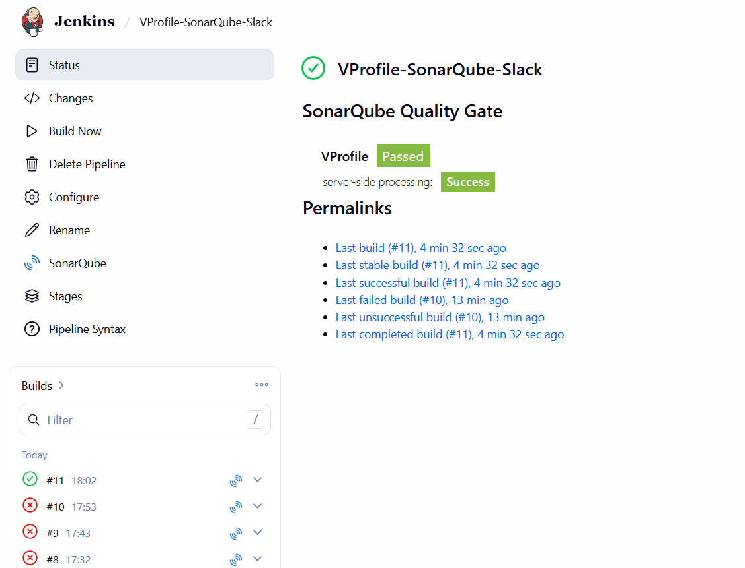

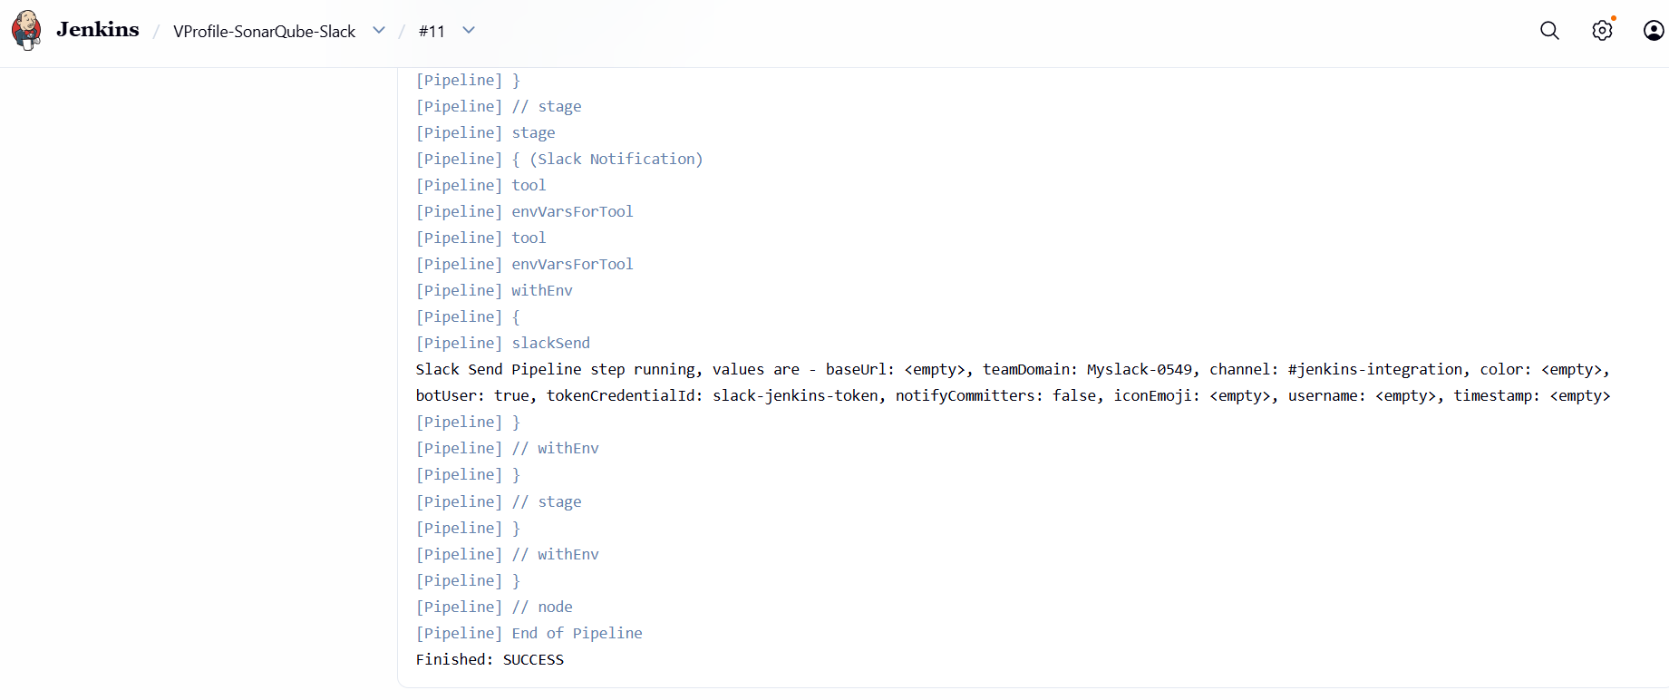
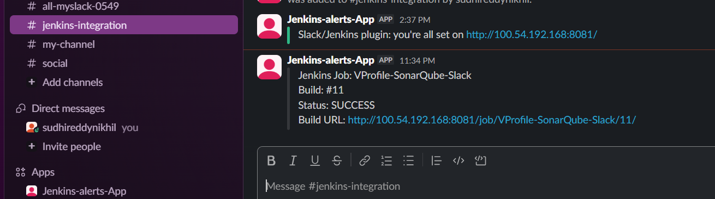

The most important troubleshooting points to remember for my Jenkins + SonarQube project are:
- Maven POM not found
  - Maven was running from /home/ec2-user.
  - Fixed by running from:
/var/lib/jenkins/workspace/VProfile-SonarQube-Slack
- SonarQube connection timeout
  - Public IP 100.27.39.78:9000 was unreachable from Jenkins.
  - Tested the private IP:
172.31.8.21:9000
  - curl returned HTTP 200, confirming private connectivity.
- SonarQube 401 Unauthorized
  - SONAR_TOKEN was not available in the manual shell.
  - Configured Jenkins credential sonarqube-token.
  - Used withCredentials to inject SONAR_TOKEN.
- SonarQube project authorization
  - Jenkins was analyzing VProfile-1, but the existing project was VProfile.
  - Changed:
-Dsonar.projectKey=VProfile
-Dsonar.projectName=VProfile
- Old Maven WAR plugin failure
  - maven-war-plugin:2.2 was incompatible with the Java/Maven environment.
  - Added:
-Dmaven.war.plugin.version=3.4.0
- SonarQube JavaScript bridge failure
  - Error:
The bridge server is unresponsive
Connection refused
  - We checked RAM, swap, processes, and OOM messages.
  - Found a stale:
target/sonar/.sonar_lock
  - Removed the stale lock as the Jenkins user.

2. Create one Jenkins job using the below code and create three stages.
- stage1: Git clone to download the source code.
- stage2: SonarQube Integration to check the quality of code.
- stage3: Slack Integration to send the alerts to slack.
Source Code: https://github.com/betawins/hiring-app.git
Since we already successfully configured the required SonarQube credential, SonarQube server, and Slack integration in Task 1, we can reuse them.

Objective
To create a Jenkins pipeline for the hiring-app application that performs source-code checkout, Maven build, SonarQube code analysis, and Slack notification after the pipeline execution.

Step 1: Create the GitHub Repository
Use the existing GitHub repository:
Repository: hiring-app
Repository URL: https://github.com/betawins/hiring-app.git
Branch: main
The repository contains the Java/Maven application and the Jenkins pipeline file.

Step 2: Configure JDK in Jenkins
- Open the Jenkins dashboard.
- Go to Manage Jenkins.
- Open Tools.
- Under JDK installations, configure Java 21.
- Give the JDK installation the name:
JDK-21
- Save the configuration.

Step 3: Configure Maven in Jenkins
- In Manage Jenkins → Tools, go to Maven installations.
- Add a Maven installation.
- Give it the name:
Maven-3.8.4
- Configure Maven 3.8.4.
- Save the configuration.

Step 4: Install and Configure SonarQube
- Open the SonarQube server.
- Access the SonarQube dashboard.
- Create a project named:
hiring-app
- Set the project key as:
hiring-app
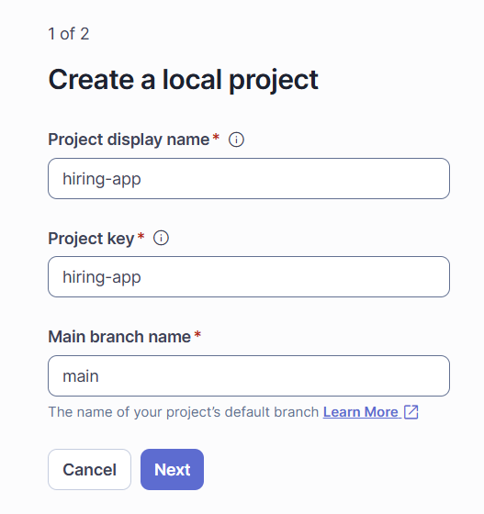
If SonarQube asks how to analyze the project, choose the option for locally / using a CI pipeline, since Jenkins will perform the analysis.
Select Jenkins
Click:
With Jenkins
Do not select GitHub Actions or Locally, because your task is:
Jenkins → SonarQube → Slack
After clicking With Jenkins, SonarQube will show Jenkins-specific setup instructions.
Select GitHub
Under Select your DevOps platform, click:
GitHub
You don't need Bitbucket or GitLab because your source repository is:
https://github.com/betawins/hiring-app.git
After clicking GitHub, SonarQube should show the next setup section.

Choose the project type
At the bottom you have:
- Maven
- Gradle
- JS/TS & Web
- .NET
- Python
- Other
So click:
Maven
After clicking Maven, SonarQube will display the Maven/Jenkins analysis command.
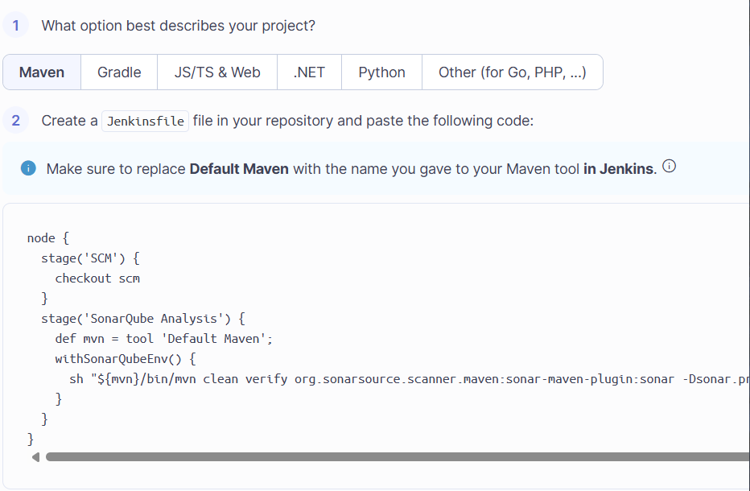
- Create a SonarQube authentication token.
- Keep the token secure because it will be used by Jenkins to authenticate with SonarQube.
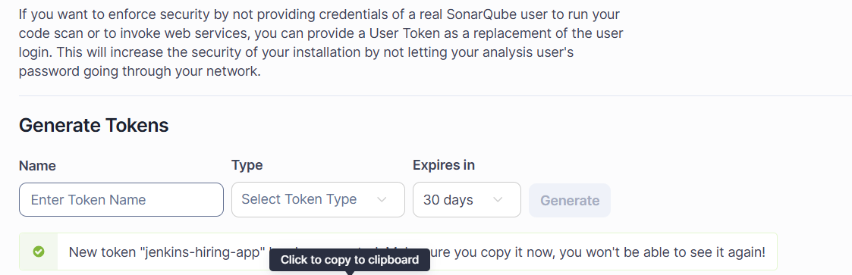

Step 5: Add SonarQube Token to Jenkins Credentials
- Open Jenkins.
- Go to Manage Jenkins → Credentials.
- Select the appropriate Jenkins credentials store.
- Click Add Credentials.
- Select:
Kind: Secret text
- Enter the SonarQube token in the Secret field.
- Set the credential ID to:
sonarqube-token
- Save the credential.

Step 6: Configure SonarQube Server in Jenkins
- Go to Manage Jenkins → System.
- Find the SonarQube servers section.
- Add the SonarQube server.
- Configure:
Name:
SonarQube
Server URL:
http://172.31.8.21:9000
- Select the SonarQube authentication credential.
- Save the configuration.

Step 7: Create the Jenkins Pipeline Job
In Jenkins:
Dashboard → New Item
Enter:
hiring-app-pipeline
Select:
Pipeline
Then click OK.
Add the Pipeline code
In the hiring-app-pipeline job configuration:
- Scroll down to Pipeline.
- For Definition, select Pipeline script.
- Paste this code:
pipeline {
agent any

tools {
jdk 'JDK-21'
maven 'Maven-3.8.4'
}

stages {

stage('Git Clone') {
steps {
git 'https://github.com/betawins/hiring-app.git'
}
}

stage('SonarQube Integration') {
steps {
withSonarQubeEnv('SonarQube') {

withCredentials([
string(
credentialsId: 'sonarqube-token',
variable: 'SONAR_TOKEN'
)
]) {

sh '''
mvn clean verify \
-Dmaven.war.plugin.version=3.4.0 \
org.sonarsource.scanner.maven:sonar-maven-plugin:5.7.0.6970:sonar \
-Dsonar.projectKey=hiring-app \
-Dsonar.projectName=hiring-app \
-Dsonar.token="$SONAR_TOKEN"
'''
}
}
}
}

stage('Slack Integration') {
steps {
slackSend(
channel: '#jenkins-integration',
message: """Jenkins Job: ${env.JOB_NAME}
Build: #${env.BUILD_NUMBER}
Status: ${currentBuild.currentResult}
Build URL: ${env.BUILD_URL}"""
)
}
}
}
}
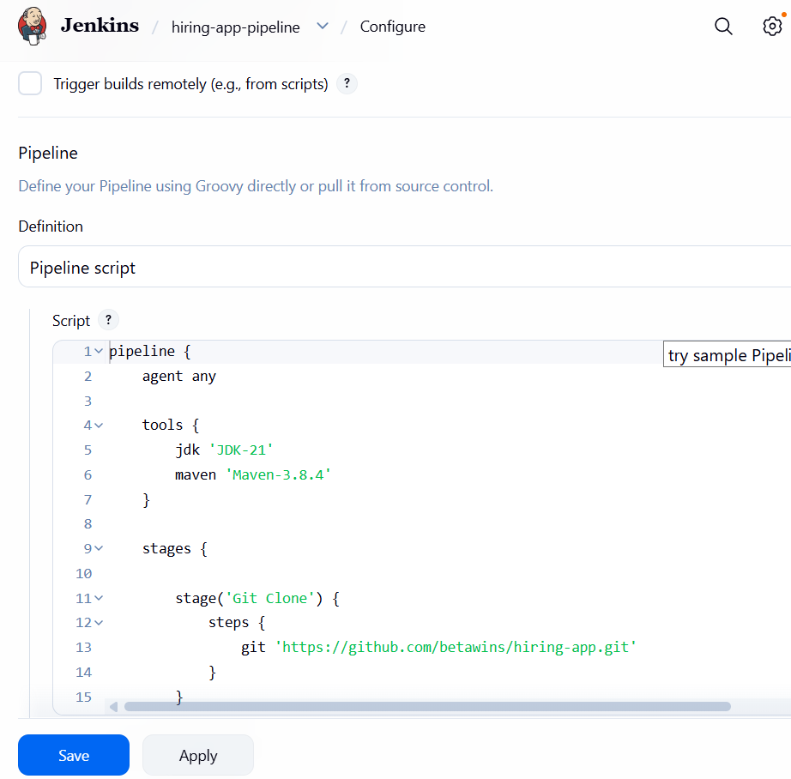

Step 8: Configure the Pipeline
In the Pipeline configuration, use the Jenkinsfile from the GitHub repository.
The pipeline contains three main stages:
- Git Clone
- SonarQube Integration
- Slack Integration

Step 9: Git Clone Stage
The Git Clone stage downloads the application source code from GitHub.
The pipeline uses:
- Repository: https://github.com/betawins/hiring-app.git
- Branch: main
After checkout, Jenkins places the application in its workspace:
/var/lib/jenkins/workspace/hiring-app-pipeline

Step 10: SonarQube Integration Stage
The SonarQube stage performs the Maven build and SonarQube code analysis.
The Maven command performs:
mvn clean verify
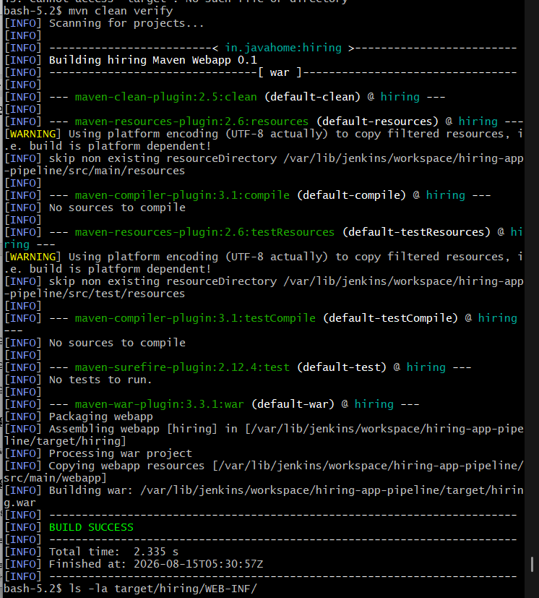
and then runs the SonarQube Maven scanner.
The analysis uses:
- Project key: hiring-app
- Project name: hiring-app
- SonarQube server: SonarQube
- Jenkins credential: sonarqube-token
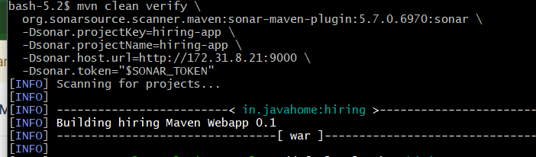
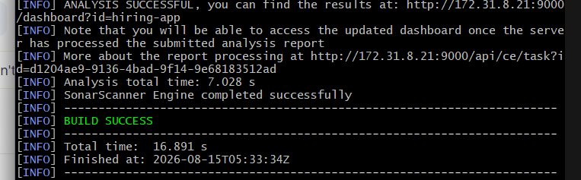
The SonarQube token is passed securely to Maven using the Jenkins credential.

Step 11: Slack Integration Stage
Configure Slack notification for the channel:
#jenkins-integration
After the pipeline finishes, Jenkins sends a notification containing:
- Jenkins job name
- Build number
- Build status
- Build URL
Example notification:
Jenkins Job: hiring-app-pipeline
Build: #6
Status: SUCCESS
Build URL: http://100.54.192.168:8081/job/hiring-app-pipeline/6/

Step 12: Jenkins Pipeline Structure
The complete pipeline flow is:
GitHub Repository
|
↓
Git Clone
|
↓
Maven Build
mvn clean verify
|
↓
SonarQube Analysis
|
↓
Slack Notification
|
↓
Build Result

Step 13: Run the Pipeline
- Open the hiring-app-pipeline job.
- Click Build Now.
- Open the generated build number.
- Click Console Output.
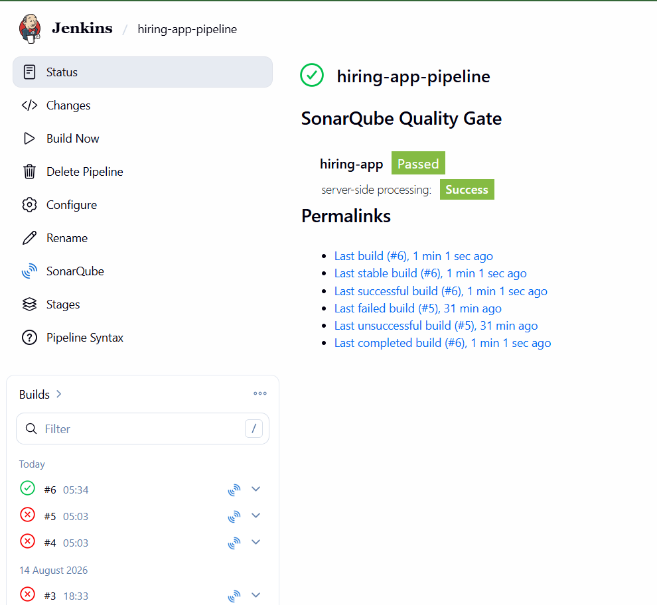
- Verify that the Git repository is checked out successfully.
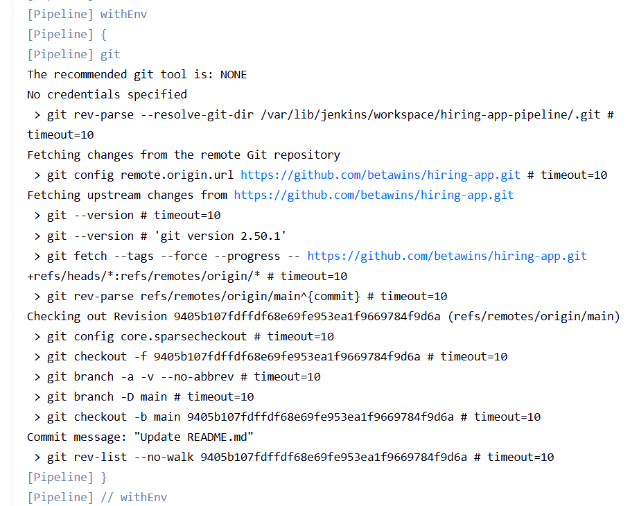
- Verify that Maven builds the application successfully.
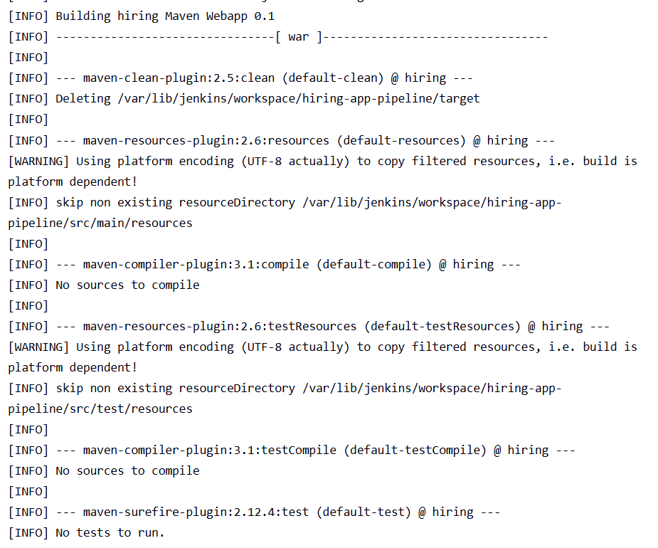
- Verify that SonarQube analysis completes successfully.
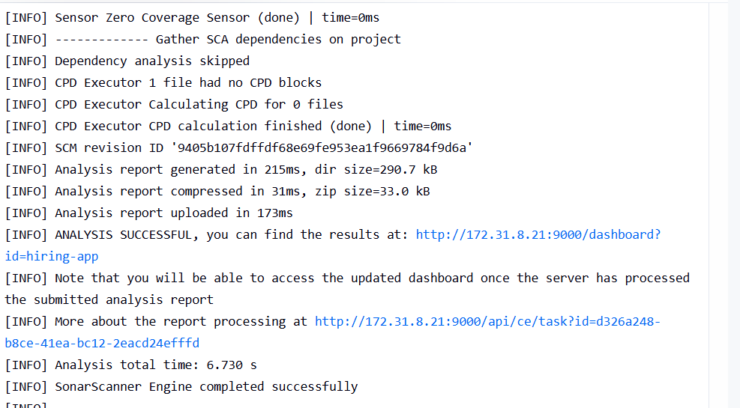

- Verify that the Slack notification is sent.
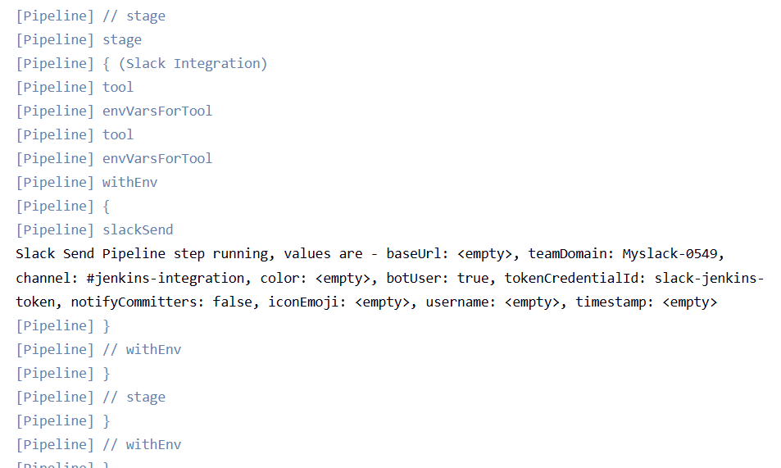

Step 14: Verify SonarQube
After a successful pipeline execution:
- Open SonarQube.
- Open the hiring-app project.
- Verify that the latest analysis is displayed.
- Check the project analysis results such as code quality, issues, security hotspots, and other available metrics.
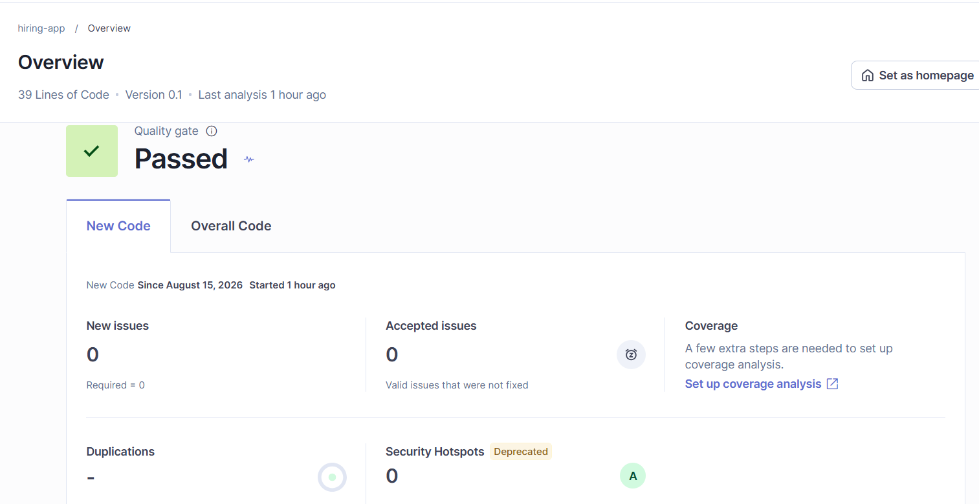

Step 15: Verify Slack Notification
Open the Slack channel:
#jenkins-integration
Verify that Jenkins has sent the build notification.
The completed pipeline produced a successful notification:
Jenkins Job: hiring-app-pipeline
Build: #6
Status: SUCCESS
Build URL: ...
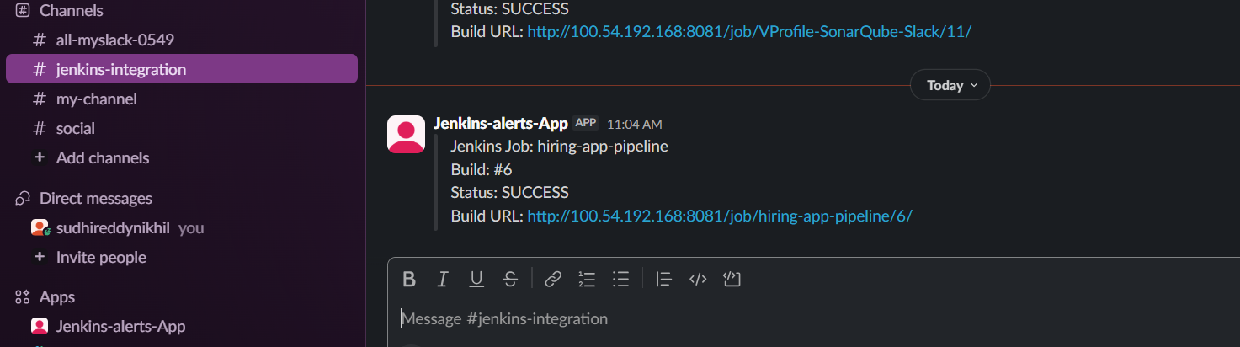

Final Result
The Application Deployment Pipeline was successfully configured and tested.
The completed flow is:
GitHub → Jenkins → Maven Build → SonarQube Analysis → Slack Notification
The pipeline successfully completed with:
Build #6 — SUCCESS

Current Task 2 Architecture
GitHub
|
| Push / Source Code
↓
Jenkins Pipeline
|
┌───────┴────────┐
↓ ↓
Git Clone Jenkins Tools
|
JDK 21 + Maven
|
↓
Maven Build
|
↓
SonarQube
hiring-app
|
↓
Slack
#jenkins-integration

important troubleshooting scenarios I faced in task 2 are:

1. Jenkinsfile Git Syntax Error

Error
The Jenkins build failed with:
Expected a step @ line 13, column 17.
git branch: 'main',

Cause
The git command was written twice in the Git Clone stage:
git branch: 'main',
git 'https://github.com/betawins/hiring-app.git'
Jenkins interpreted the second git as another pipeline step, which caused the compilation error.

Resolution Steps
- Open the Jenkins job.
- Go to Configure.
- Open the Pipeline section.
- Edit the Jenkinsfile.
- Replace the incorrect Git configuration with:
git branch: 'main',
url: 'https://github.com/betawins/hiring-app.git',
credentialsId: 'github-credentials'
- Replace github-credentials with the actual Jenkins GitHub credential ID.
- Save the configuration.
- Click Build Now.
- Open Console Output.

Validation
The Git stage should execute successfully and show that the repository was checked out from the main branch.
Result: ✅ Git checkout completed successfully.

2. SonarQube Token Was Not Available

Problem
We checked whether the SonarQube token was available to the Jenkins user using:
sudo -u jenkins bash
cd /var/lib/jenkins/workspace/VProfile-SonarQube-Slack
echo "Token configured: ${SONAR_TOKEN:+YES}"
The output was:
Token configured:

Cause
The SONAR_TOKEN environment variable was not automatically available in the Jenkins user's normal shell environment.

Resolution Steps
- Open Jenkins.
- Go to Manage Jenkins → Credentials.
- Open the appropriate credential store.
- Select Global credentials.
- Create a new credential.
- Select Secret text.
- Enter the SonarQube authentication token in the Secret field.
- Set the credential ID as:
sonarqube-token
- Save the credential.
- Update the Jenkinsfile to inject the credential:
withCredentials([
string(
credentialsId: 'sonarqube-token',
variable: 'SONAR_TOKEN'
)
]) {
...
}
- Use the variable in the Maven SonarQube command:
-Dsonar.token="$SONAR_TOKEN"

Validation
For a safe test, we used:
echo "Token configured: ${SONAR_TOKEN:+YES}"
Expected output:
Token configured: YES
We did not print the actual token.
Result: ✅ SonarQube token was securely injected through Jenkins Credentials.

3. SonarQube Project Authorization Error

Error
The Maven SonarQube analysis failed with:
You're not authorized to analyze this project or the project doesn't exist
on SonarQube and you're not authorized to create it.

Cause
The Jenkins pipeline was configured with:
sonar.projectKey=hiring-app
sonar.projectName=hiring-app
but the hiring-app project had not yet been created in SonarQube.
The SonarQube user associated with the Jenkins token also needed sufficient permissions.

Resolution Steps
- Open the SonarQube dashboard.
- Go to Projects.
- Select Create Project.
- Select Manually.
- Enter:
Project name: hiring-app
Project key: hiring-app
- Create the project.
- Open the project settings.
- Go to Permissions.
- Verify that the user associated with the Jenkins token has permission to perform analysis.
- Return to Jenkins.
- Run the pipeline again.

Validation
The SonarQube stage should complete without the authorization error.
The hiring-app project should then be visible in the SonarQube dashboard with the latest analysis.
Result: ✅ SonarQube project and permissions were configured.

